Committee of the Dee
Launch Driving - Instructions and Guidance
Updated 8/2/2023 adding requirement to carry a mobile phone.

Checklist before Using launch
Check tides (see appendix A)
- Check all sponsons are fully inflated (if applicable)
- Check drain bung is in place
- Check plenty fuel (petrol only with no oil)
- Check safety inventory
  - Paddle
  - Throw line (rescue line to throw to someone in water)
  - Inflation pump (if applicable)
  - Mobile phone (in waterproof cover, if required)
- Maximum of two people in the launch for coaching purposes.
- Launches cannot be used in the dark (between sunset and sunrise as on tide tables).

Personal equipment before using launch
- Warm clothing
- Lifejacket

Launching the launch
- Take care when moving launch on land :
  - Ensure trolley wheels are not rubbing on hull.
  - Protect the transom from damage by avoiding bumping the trolley (or support the engine over any bumps).
- Put trolley in water.
- Untie painter (bow line).
- Float launch off trolley whilst holding end of painter.
- Retrieve trolley and leave in a safe place.

Starting the engine
- Get driver and any passenger into launch.
- Ensure that painter is inside launch and cannot fall out (this might risk fouling the propeller)
- Use paddle to move away to a safe depth.
- Attach kill cord securely to an item of your clothing.
NB failure to do this is an ‘instant fail’ offence
- Ensure that engine control is in neutral (vertical) position
- Lower engine
- Open breather screw on top of petrol tank.
- Prime fuel supply by squeezing rubber bulb slowly several times.
- If engine is cold, then pull out choke.
- Pull cord to start engine
- Allow engine to warm up before use.
- If required, use fast-idle lever on control unit to avoid stalling.
- Push choke back in as soon as possible.

Driving the launch (general)
- Keep good all-round observation at all times.
Look to your sides and behind as well as in front.
- Drive slowly when possible to reduce wash.
- Be gentle when changing between forward and reverse gears to avoid damage to the transmission.
- Slow down when passing other crews, especially small boats.
- Coaching a crew gives you no special rights over other river users.
- If you have a passenger it may help if they sit forward to avoid the bow of the launch rising.

Driving the launch (manoeuvring)
- At low speed you will need to use larger wheel movements. When moving faster, only small movements of the wheel should be used. At speed, sudden or large movements of the wheel can make the launch unstable.
- For tight manoeuvring the order is:
  - Engine in neutral
  - Turn wheel in desired direction
  - Then apply gentle power in desired direction
This is much more effective than moving the wheel whilst the engine is in gear.
- Try to only use light throttle in reverse. Excessive throttle or boat speed in reverse can cause pooping (water splashing over the transom into the boat).

Driving the launch (beaching)
- Check all round for other crews in area. Give way to rowing boats.
- Approach land at 90° to bank, taking account of wind and stream.
- At an appropriate distance from shore, put engine in neutral; stop engine; raise motor and latch propeller out of water.
- The boat should drift gently to the shore, bows first.
- If in doubt, stop engine earlier and use paddle to get to shore rather than grounding at speed.
- Secure launch safely, taking account of state of tide.

Returning launch to trolley and boathouse
- Hold end of painter.
- Float launch out and manoeuvre trolley underneath launch.
- Pull trolley and launch gently out of water
- Ensure that launch is sitting correctly on trolley. It must be straight and at an appropriate distance onto the trolley. A lot of hull damage has been caused to the inflatable launches by failing to check this before the trolley is moved away from the shore.
- Again, avoid excessive bumping unless you support the motor. This is to prevent damage to the transom.
- If there is water in the launch, remove drain bung and gently tip up bow to empty. Do not raise the bows too far as the launch might slip off the trolley.
Replace the bung in case the launch has to be used in an emergency.
- Always leave enough petrol in the tank to allow it to be used in an emergency. It is not advised to run the tank dry as debris from the tank can enter the fuel lines.

Rescuing people from the water.
You must be aware of the benefits, and risks, of approaching a capsized rowing boat in a rescue launch. In an emergency situation it is easy to put other people (including yourself) into new danger unless you assess the situation and approach with care.
Some basic principles:
- Look around to assess the situation – take into account other boats, bridges, stream, safe landing places and dangerous obstacles. Do all of this before rushing into the danger zone.
- Your propeller can chop off feet and arms!
- Try and exude an aura of calm (even if you do not feel it) and try to quieten any panic in the rowers. Remember that you are in charge of the launch and no-one should be telling you what to do. The reassuring presence of the launch nearby is sometimes all that rowers need if they are able to rescue themselves by towing the rowing boat towards land. You are in a better position to assess risks and formulate a rescue plan – you should explain this clearly to the rowers.
- Do a head count as soon as you arrive on the scene to ensure that everyone is accounted for.
- People are more important than boats, blades, seats, jackets etc.
- It is very difficult to get someone into the launch from deep water – you risk capsizing the launch and increasing the casualty count.
- Rowing boats float and it is often best to keep crew and rowing boat together and manoeuvre everything to land.
- You should have identified a safe landing area on your initial assessment. Remember than a landing zone further downstream may be more practical then a closer one upstream.
- One of the safest ways of helping rowers towards land is to get one, or more, of them to hold onto the bows of the launch and for you to very slowly tow them in reverse towards the shore. This avoids risk from rowers coming in contact with the propeller.
- Alternatively, you could use the bows of the launch to very gently push the boat and rowers towards safety. Watch out for your propeller and be prepared to kill the engine immediately if anyone is swept towards it.
- Remember the dangers of hypothermia, especially if wind-chill is present (including high-speed travel in a launch).
- Once at the bank, you can consider the appropriateness of transferring rowers back to the clubhouse in the launch. At most, you can take only two rowers at a time. Use gentle throttle if the launch is loaded as it will tip more readily. It may be safer to arrange for rowers to be picked up by car. Never allow cold and wet rowers to start walking back to the clubhouse unaccompanied – they can rapidly become very cold. Try and secure boats, blades, clothing etc but only after people are safe. It is often better to go back later for boats and blades after rowers are safely in the clubhouse.
- Showers are not effective for rewarming cold rowers. It is better to get them out of (all) wet clothes and into dry clothes then wrap them up out of the wind. Blankets and huddling together to share body heat are useful.

Appendix A
Rowing limits round low tide
Height of low tide (m) | Rowing restrictions round low tide
< 0.5 | +/- 2 hours
0.5 – 1.2 | +/- 1.5 hours
1.2 – 1.3 | +/- 1 hour
> 1.3 | No restriction

Appendix B
Terms with which you must be familiar (see diagrams on the following page)
You must be familiar with these terms and be able to describe the function, use and action of the following:

Item | Description / function
Sponson | Inflatable tube round hull that provided rigidity and buoyancy to launch
Foot pump for sponsons | You must demonstrate use of this.
Transom | Rigid board at stern that outboard motor is bolted on to.
Painter | Bow line. Rope attached to the bow – used during launching and beaching. Also to secure launch when on shore in a rising tide. Important to ensure this does not foul the propeller.
Kill cord (safety lanyard) | This must be attached to the driver at all times when the engine is running. This ensures that the launch will stop if the driver falls overboard.
Engine control (forward/reverse and throttle) | Does exactly what it says on the tin ! Should be used gently – this will reduce wear on equipment and wash. You need to lift the safety latch before it will move out of neutral (vertical) position. Avoid changing suddenly between forward and reverse gears as this can damage the transmission.  Also has a control to increase idling speed of the engine. Useful if engine is stalling when cold. Return to normal position ASAP.
Choke | Pull out fully to start a cold engine.  Return to half-way position ASAP.  Push in fully ASAP.
Primer bulb on fuel supply | Used to clear any air-locks in fuel supply. Generally only needed on first starting. May be needed again if engine has been raised (but try without first to reduce risk of flooding engine)
Engine raising latch | Used to allow engine to be lowered into water and also to latch engine in raised position.

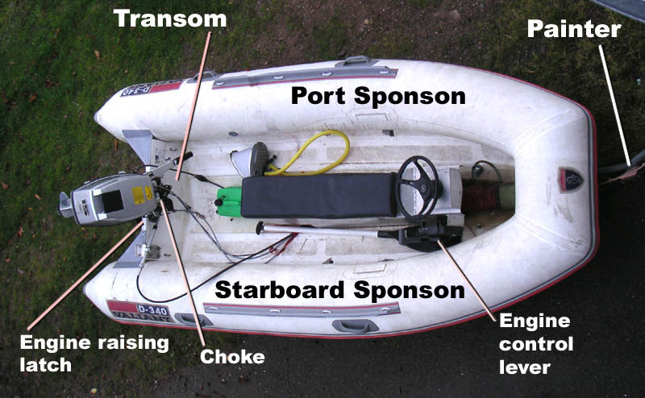

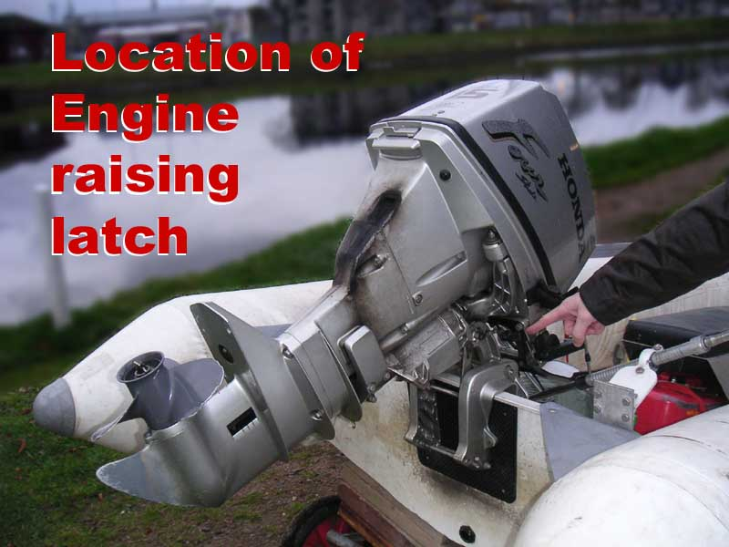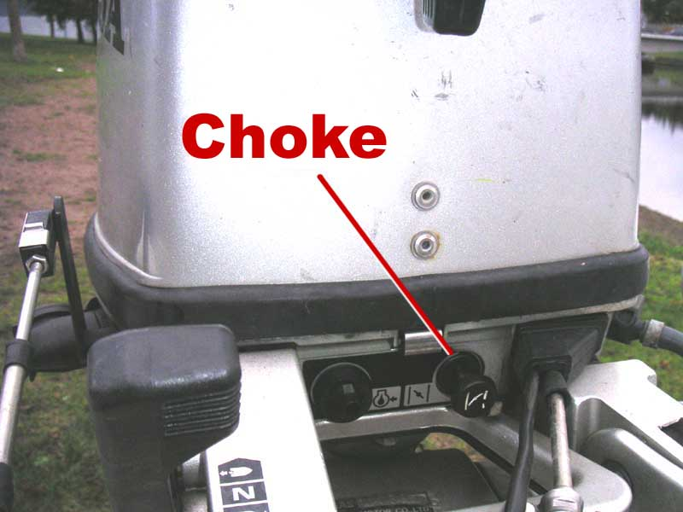

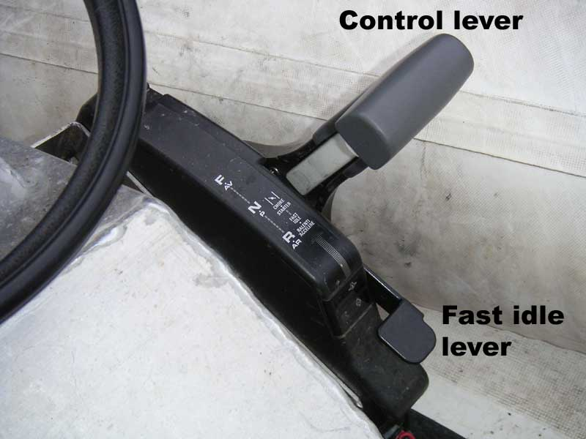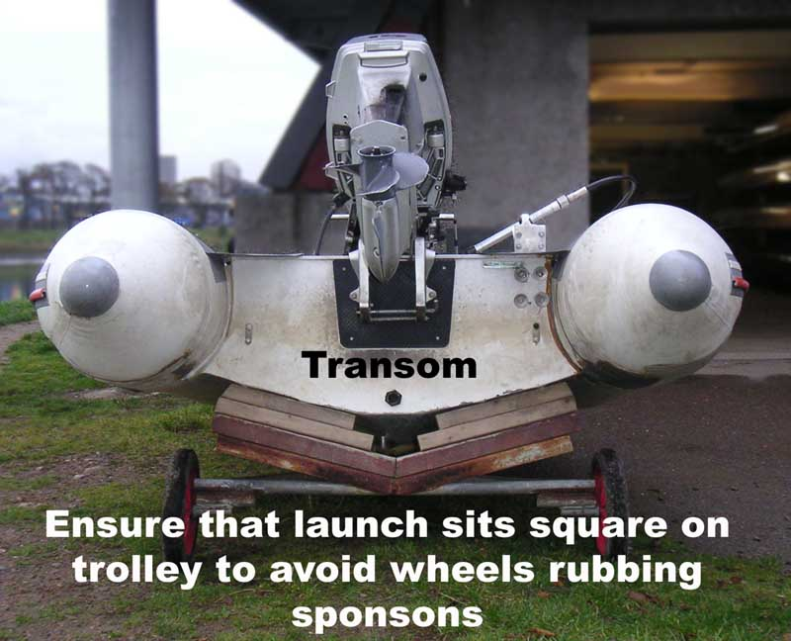

Committee of the Dee
Launch Driving Test (1) - declaration
(to be completed by all launch users regardless of level of experience)

To be completed by Candidate
Name
email address
Club(s) for which you will be driving (main first)
Reason(s) for driving launch  (tick all that apply) | Coaching  Safety  Other (specify)
All new drivers must complete the form on the following page listing four outings with a qualified driver. If you are applying to waive this requirement then list your reasons, and experience, here.
Which launch will you mainly use?

I confirm that I understand the following:

- I have read the document Launch Driving – Instructions and Guidance produced by the Committee of the Dee (CofD) and I will adhere to its guidance at all times.
- That use of the launches is restricted to purposes directly involved in the sport of rowing. This includes coaching, filming, safety purposes, marshalling at regattas, laying buoys etc.
- That the launches must not be used for recreational purposes not connected with rowing. Anyone seen ‘joyriding’ in a launch risks restriction of permissions.
- That when I am driving the launch it is entirely my responsibility to ensure safety of the launch, any passengers and other river users.
- Launches are restricted to use on the River Dee and are subject to the same tidal and limit restrictions as rowing boats (< 3 bricks showing for Railway Bridge and < 1 brick for King George VI Bridge)
- I will report any damage immediately.
- If I see these rules being broken by anyone, I will report this to the CofD.
- Breaking of launch driving rules may result in permission to use CofD launches being revoked for me or my club.
- The Committee of the Dee retains overall responsibility for approving use of launches regardless of whether or not a test has been passed. They also may alter these rules in the future and I agree to adhere to any such new rules.

Signed Date

(This must be signed and passed to Ron Wallace of the Committee of the Dee)
Committee of the Dee
Launch Driving Test (2) – practical supervision

Name of Candidate

Any new launch driver must shadow a qualified driver (QD) on at least four separate occasions before they can drive solo. This does not need to be the same QD on each occasion. This rule can be waived for existing drivers with suitable experience.
The qualified driver remains responsible for the launch during these outings.
The QD should encourage the candidate to take a hands-on approach as much as possible whilst retaining overall responsibility for the candidate’s actions. The candidate can drive the launch as long as the QD is satisfied as to their competence.
The QD must sign each outing and is encouraged to add comments as to:
points covered,
what was done well
what areas need further work.
The candidate should ensure that, by the end of the 4th outing, they have personally undertaken a full range of activities including (tick boxes as done);
on-land preparation launching the boat starting engine
manoeuvring on water landing the boat
putting the boat back on trailer again

Date | Areas covered / activity undertaken | Comments | Name and signature of qualified driver

Having signed the declaration on page 6, and after having at least four supervised outings, you should return pages 6 and 7 to Ron Wallace. The CofD will then consider your application.

